CURRICULUM VIATE

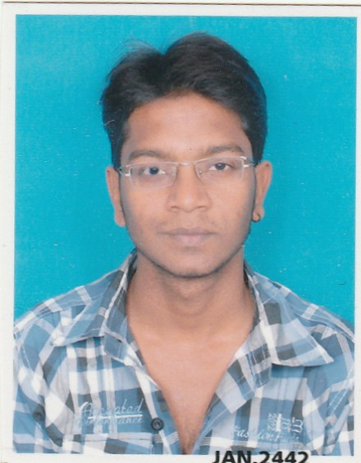
Dhwanil Panchal
Address:- 20, Janki Duplex , B/H Revapark,
Waghodia Road , vadodra -399019

Mobile: +918460411779
Email: dhwanil.mechanical@gmail.com
Skype: - Dhwanil.panchal

CAREER OBJECTIVE

To work in a firm with a professional work driven environment where I can utilize and apply my knowledge, skills which would enable me as a fresh graduate to grow while fulfilling organizational goals.

BASIC ACADEMIC CREDENTIALS

Qualification | Board/University | Year | CLASS
B.Tech  (Mechanical) | SAMARTH CAMPUS (REGULAR PROGRAMME) | 2013 | 71 %
Diploma Mechanical | GUJARAT UNIVERSITY | 2010 | 59.66 %
S.S.C | GUJRAT BOARD | 2007 | 70.77 %

WORK EXPERIANCE

- PRITAM ENGINEERS & MANUFACTURERS

Company is mainly concern with Gunnebo India Pvt.Ltd and they are manufacturing about 250 to 300 different types of locker and ATM machine parts, also doing maintenance job of some company like Steelco Gujrat Pvt Ltd, Banco Alluminium Ltd, Raychem Rpg Pvt Ltd etc.

Role and responsibilities :

- Monitoring daily production as per monthly oreder
- Purchasing
- Manpower planning as per capacity
- Corrective & preventive action (CAPA) in time for process deviation, internal rejections and customer complaints
- Quality standards and updated the PPAP records, problem solving tools like KAIZEN, 5S, KANBAN systems.

- BANCO PRODUCTS INDIA PVT. LTD

I am presently associated with BANCO PRODUCTS INDIA PVT. LTD under capacity of production planning engineer in fabrication department since June 2015. Company is manufacturing various types of Heat exchangers for OEM, Replacement and Export customers.

Role and responsibilities :

- Material feeding as per daily planning for our assembly line to achieve monthly target.
- Procurement of raw material with co-ordination with purchase.
- To meet sales budget on monthly basis
- SAP related activities as per daily requirement
- To analyze and maintain inventory
- Maintain and update BOM in ERP system
- Generating daily, monthly and yearly reports for management

EXPERIENTIAL LEARNING

    - Company Name :- Pakona Engineers India Pvt. Ltd
    - Project Title :- Production planning .
    - Duration :- one Months (24th May’10 to 24th june’10)

PROJECTS

- Auto sensor drill machine
Through the use of precision components, advanced software, the latest sensing technologies, robust drilling capabilities, and automated fastening, the CAD-CAM machine enables the automated drilling and temporary fastening of the latest designs in composite/metallic wing box assemblies.

- Electro- Magnetic crane
It is very useful in steel industries, by use of electro magnet handling of scrap material and steel product very easily. When electric current is supplied magnet is charged and work as heavy magnet.

IT PROFICIENCY

- SAP ( pp module)
- Pro/E wildfire
- Creo v.2
- CNC Programming
- Microsoft Office Word, Microsoft Office Excel
- Internet Browsing

INTERPERSONAL SKILL

  - Ability to rapidly build relationship and set up trust.
  - Confident and Determined
  - Ability to cope up with different situations.
  - Sincere and hard working

PERSONAL DETAILS

Father Detail :-Satishkumar Panchal

Date of Birth :-4th January, 1992

Gender :-Male

Marital Status :-Single

Nationality :-Indian

Language Known :-English, Hindi, Gujarati

Hobby :-Music, Cricket

Specialty :-Effective group leading, Innovative thinking

DECLARATION

I hear by declare that the information given above are true and honest to the best of my knowledge. I commit to discharge my duties in the best possible manner

Dhwanil panchal
(Signature)

